Sync Splash Screen

User flow

Sync on IAM
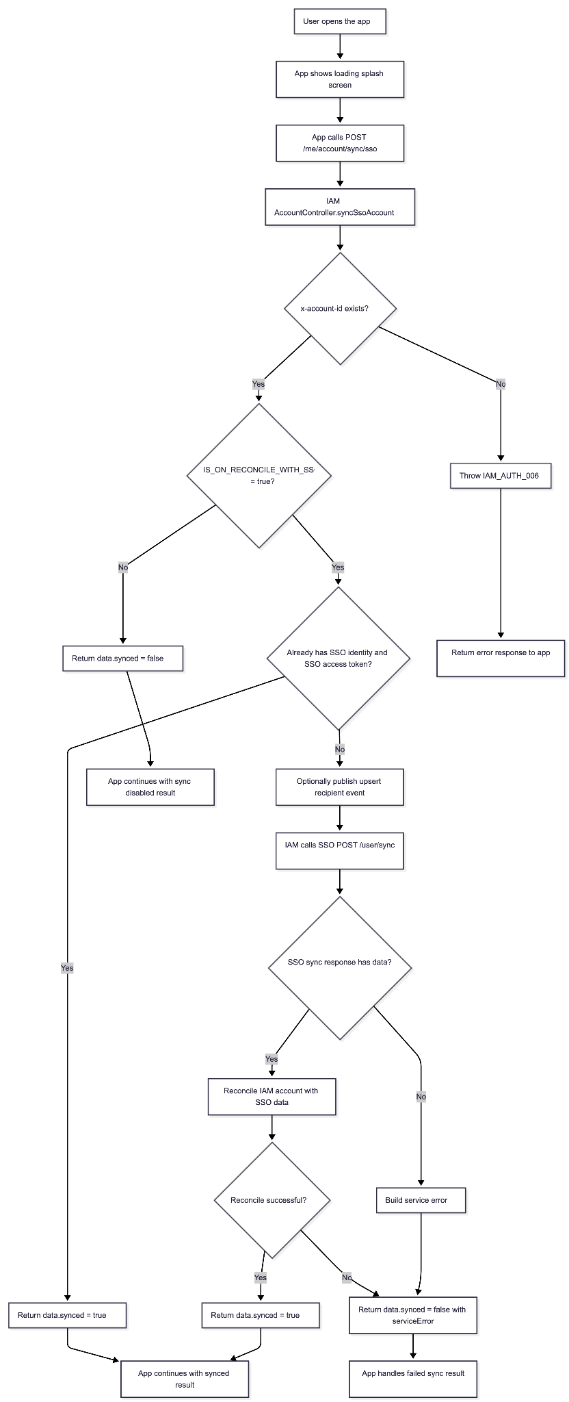

Sync on SSO
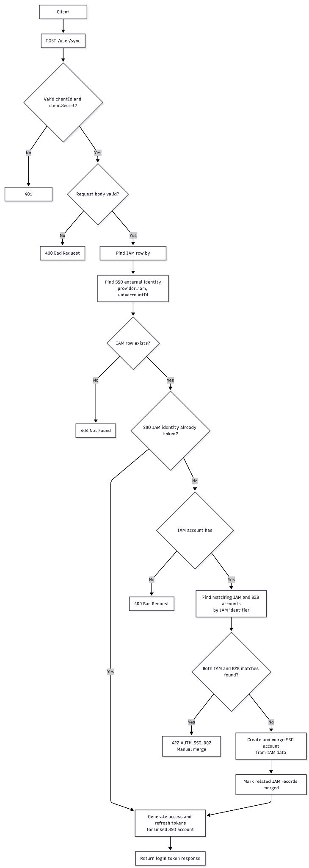

Reconcile flow
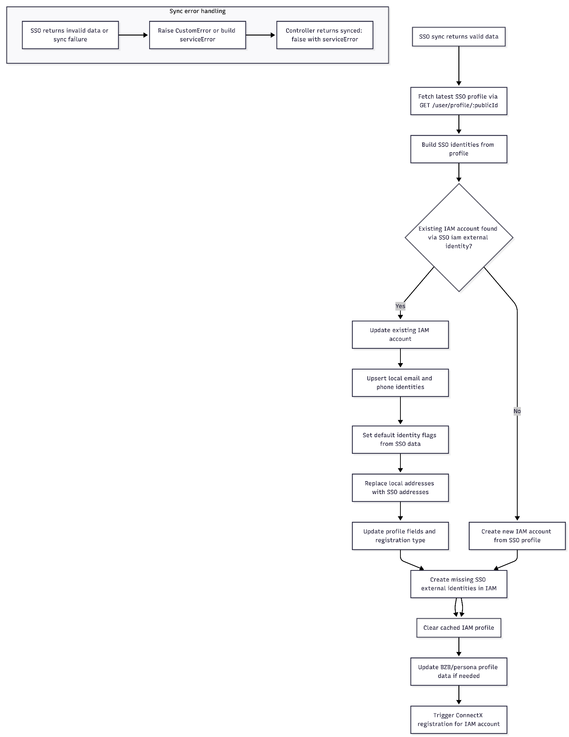

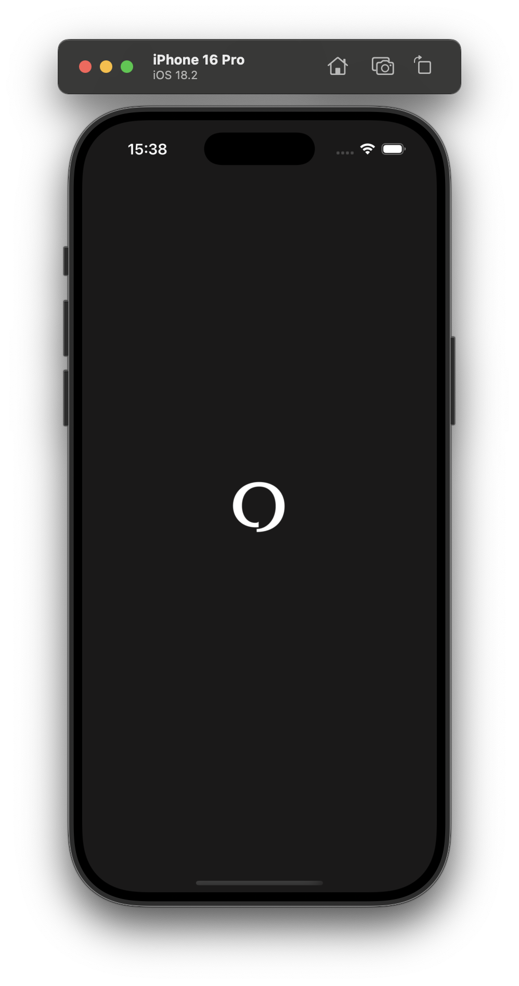
Preview Screen


Sequence Diagram

Sync flow
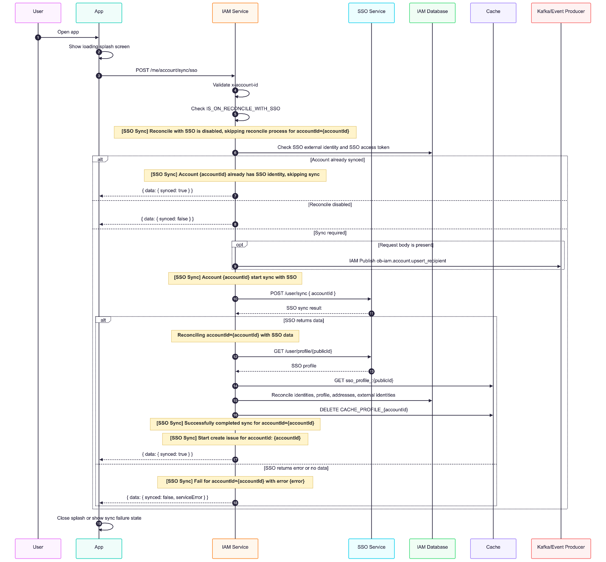

Reconcile flow

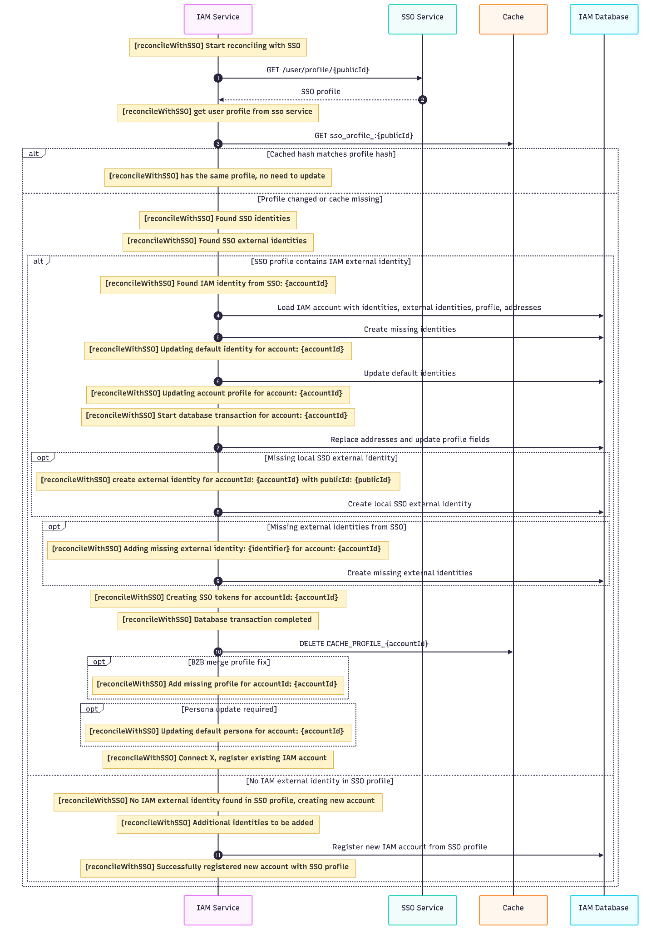

Environment & Cache keys
Name | Example | Purpose
IS_ON_RECONCILE_WITH_SSO | true | Feature flag for this flow. When this is not exactly true, POST /me/account/sync/sso skips SSO reconcile and returns synced: false.
OB_SSO_URL | https://sso.example.com | Base URL used by SSOClient for all SSO API calls in this flow, including POST /user/sync and GET /user/profile/{publicId}.
OB_SSO_CLIENT_ID | abcd1234 | Client credential header sent to the SSO service.
OB_SSO_CLIENT_SECRET | defh5678 | Client credential secret sent to the SSO service.

Related Cache Keys
Key | Source | Purpose
sso_profile_:{publicId} | AccountService.reconcileWithSSO | Stores the hashed SSO profile used to detect whether the fetched SSO profile is unchanged. If the hash matches, reconcile exits early with no update.
CACHE_PROFILE_{accountId} | ProfileService via CACHE_PROFILE_KEY = 'CACHE_PROFILE' | Cached IAM profile payload. Reconcile deletes this key after updating the account so the next profile read is refreshed.

Cache Notes
- cache.get('sso_profile_:{publicId}') is used during reconcile before profile update work starts.
- cache.set('sso_profile_:{publicId}', ...) is currently present in code as a commented line, so the read path exists but the write path is not active.
- cache.delete('CACHE_PROFILE_{accountId}') runs after the database transaction completes for an existing IAM account reconcile path.

Api description

Sync sso - IAM

Description
Sync and reconcile the current IAM account with SSO.

Example Request
POST /me/account/sync/sso
x-account-id: acc_123
Content-Type: application/json

Headers
Name | Required | Description
x-account-id | Yes | Current IAM account ID. The controller throws IAM_AUTH_006 if it is missing.

Success Response
{
"data": {
"synced": true
}
}

Sync Disabled Response
When IS_ON_RECONCILE_WITH_SSO is not true, IAM skips reconciliation.

{
"data": {
"synced": false
}
}

Failed Sync Response
The controller catches SSO and reconciles errors and returns a normal wrapped response with synced: false.
{
"data": {
"synced": false,
"serviceError": {
"message": "error message",
"details": {
"fullName": "Jane Doe"
}
}
}
}

3.2 Sync sso - SSO

Description
The request does not accept a password from the caller. Instead, the service loads the IAM account by accountId, verifies that the IAM record has a stored password, and uses the trusted sync path to create or reuse the matching SSO account.

Example Request
POST /user/sync HTTP/1.1
Content-Type: application/json
clientId: xxx
clientSecret: xxxx
{
"accountId": "iam-account-001"
}

Headers
Name | Type | Required | Description
clientId | string | Yes | OAuth client ID used by ClientAuthGuard.
clientSecret | string | Yes | OAuth client secret used by ClientAuthGuard.
Content-Type | string | Yes | Must be application/json.

Request Body
Field | Type | Required | Description
accountId | string | Yes | IAM account ID to synchronize. Must be a non-empty string.

Success Response Status: 200 OK
The endpoint returns the same token shape as a login response.
{
"data": {
"accessToken": "eyJhbGciOiJIUzI1NiIs...",
"refreshToken": "eyJhbGciOiJIUzI1NiIs...",
"expiresIn": 3600,
"publicId": "sso_1234567890",
"tokenType": "Bearer",
"scope": "read write"
}
}

Error Responses
Status Code | Condition | Source
400 Bad Request | Request body is invalid, such as missing or empty accountId. | syncIamDtoSchema
400 Bad Request | IAM account exists but has no password. | processIamAccountSync
401 Unauthorized | Missing or invalid clientId / clientSecret. | ClientAuthGuard
401 Unauthorized | Merge cannot authenticate or match the IAM account during account creation. | AuthService.createAndMergeAccount
404 Not Found | No IAM row exists for the provided accountId. | UserService.syncIam
404 Not Found | Token generation receives an SSO account ID that no longer exists. | generateLoginResponse
422 Unprocessable Entity | AUTH_SSO_002: account merge finds both IAM and BZB accounts and conflict handling is enabled by createAndMergeAccount. | AuthService.createAndMergeAccount
500 Internal Server Error | Account creation or token persistence fails unexpectedly. | Auth/account creation services

Example not found response:
{
"statusCode": 404,
"message": "[Sync IAM] No IAM or SSO account found for accountId=iam-account-001",
"error": "Not Found"
}

Example missing password response:
{
"statusCode": 400,
"message": "Account iam-account-001 has no password set",
"error": "Bad Request"
}

Example IAM/BZB merge conflict response:
{
"status": 422,
"error": {
"code": "AUTH_SSO_002",
"message": "Found identifier on both iam and bzb account, please merge name: John Doe"
}
}

